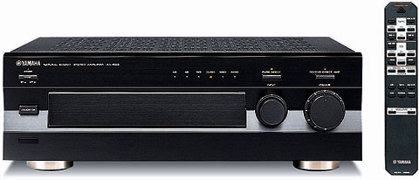

Yamaha AX-596
Link: http://www.yamaha.co.jp/english/product/av/products/hf/ax596.html

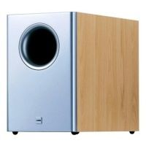

Canton AS 20 SC
Link: http://de.shopping.com/xPF-Canton_AS_20_SC

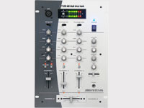

2-mal JB Premium Mixer
Link: http://www.disco-store.at/link-beglec.htm

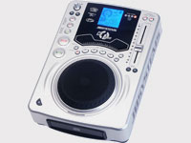

2-mal JB CD 200
Link: http://www.beglec.com/products.php?product=325&lang=EN

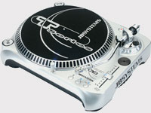

2-mal JB T2 Direct Drive Turntabels

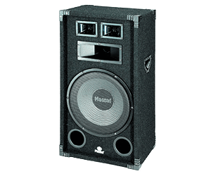

3-mal Magnat Soundforce 1300
Link: http://de.shopping.com/xPF-Magnat_Magnat_Soundforce_1300

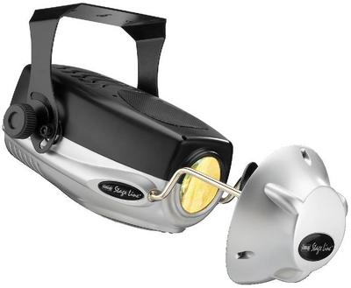

2-mal Light Effect unit “Scanner” LE 190
Link: http://www.ts-audio.de/tsshop3/WGS/16/PRD/LE-190/Lichteffektgeraet_%22Scanner''.htm

Fog Machine FM-1002
Link: http://monacor.com/de/FLE/FM1002.pdf

Zubehör:

2-mal 6er Stecker von Supra-Line
2-mal Professional Phono & Microphono Pre-Amp (Verstärker für Schallplattenspieler)
1-mal Mikrofon
1-mal JB Kopfhörer

